**Flutter App Development Course**

**DAY # 6**

**Task 1:**

**Source Code:**

**Main.dart**

import 'dart:html';

import 'package:flutter/material.dart';

import 'package:font_awesome_flutter/font_awesome_flutter.dart';

import 'package:ms_class06/result.dart';

import 'conatinerWid.dart';

import 'icon_content.dart';

import 'constants.dart';

import 'bottomButton.dart';

import 'calculator_brain.dart';

// BottomContainerHeight

enum Gender {

male,

female,

}

void main() {

runApp(MyApp());

}

class MyApp extends StatelessWidget {

// This widget is the root of your application.

@override

Widget build(BuildContext context) {

return MaterialApp(

theme: ThemeData.dark(),

debugShowCheckedModeBanner: false,

home: InputPage(),

);

}

}

// ====================================================

class InputPage extends StatefulWidget {

@override

_InputPageState createState() => _InputPageState();

}

class _InputPageState extends State<InputPage> {

Gender selectedGender;

int height = 5;

int weight = 50;

int age = 20;

// Color maleCardColor = inactiveCardColor;

// Color femaleCardColor = inactiveCardColor;

// void updateColor(Gender selectedGender) {

// if (selectedGender == Gender.male) {

// // male

// if (maleCardColor == inactiveCardColor) {

// maleCardColor = activeCardColor;

// femaleCardColor = inactiveCardColor;

// } else {

// maleCardColor = inactiveCardColor;

// }

// }

// if (selectedGender == Gender.female) {

// // Female

// if (femaleCardColor == inactiveCardColor) {

// femaleCardColor = activeCardColor;

// maleCardColor = inactiveCardColor;

// } else {

// femaleCardColor = inactiveCardColor;

// }

// }

// }

@override

Widget build(BuildContext context) {

return Scaffold(

appBar: AppBar(

title: Center(child: Text("Shahab's BMI App", style: TextStyle(color: Color(0xff820308) ,fontSize: 25,fontWeight:FontWeight.bold),)),

),

body: Column(

children: [

Expanded(

child: Row(

children: [

Expanded(

child: ContainerWid(

onPress: () {

setState(() {

selectedGender = Gender.male;

print("Male btn is pressed");

});

},

colour: selectedGender == Gender.male

? kactiveCardColor

: kinactiveCardColor,

cardChild: IconContent(

icon: FontAwesomeIcons.mars,

label: "MALE",

),

)),

Expanded(

flex: 1,

child: ContainerWid(

onPress: () {

setState(() {

selectedGender = Gender.female;

print("Female btn is pressed");

});

},

colour: selectedGender == Gender.female

? kactiveCardColor

: kinactiveCardColor,

cardChild: IconContent(

icon: FontAwesomeIcons.venus,

label: "FEMALE",

),

)),

],

)),

Expanded(

child: ContainerWid(

colour: kinactiveCardColor,

cardChild: Column(

mainAxisAlignment: MainAxisAlignment.center,

children: [

Text(

"HEIGHT",

style: klabelTextStyle,

),

Row(

mainAxisAlignment: MainAxisAlignment.center,

crossAxisAlignment: CrossAxisAlignment.baseline,

textBaseline: TextBaseline.alphabetic,

children: [

Text(height.toString(), style: kNumberTextStyle),

Text(

"ft",

style: klabelTextStyle,

),

],

),

SliderTheme( data: SliderTheme.of(context).copyWith(

thumbShape: RoundSliderThumbShape(enabledThumbRadius: 12),

overlayShape: RoundSliderOverlayShape(overlayRadius: 30),

// overlayColor: Colors.white10,

thumbColor: Colors.red,

activeTrackColor: Colors.red

),

child: Slider(value: height.toDouble(),

min: 3 ,

max: 7,

activeColor: Colors.red ,

inactiveColor: Colors.red[900] ,

onChanged: (double newValue){

setState(() {

height = newValue.round();

});

print(newValue);

},

),

),

],

),

),

),

Expanded(

flex: 1,

child: Row(

children: [

Expanded(

flex: 1,

child: ContainerWid(

colour: kinactiveCardColor,

cardChild: Column( mainAxisAlignment: MainAxisAlignment.center,

children: [

Text("WEIGHT",style: klabelTextStyle,),

Text(weight.toString(), style: kNumberTextStyle,),

Row( mainAxisAlignment: MainAxisAlignment.center,

children: [

RoundIconButton(icon: FontAwesomeIcons.minus, onpress: (){

setState(() {

weight--;

});

}, ),

SizedBox(width: 20,),

RoundIconButton(icon: FontAwesomeIcons.plus,onpress: (){

setState(() {

weight++;

});

},),

],

)

],

),

)),

Expanded(

flex: 1,

child: ContainerWid(

colour: kinactiveCardColor,

cardChild: Column( mainAxisAlignment: MainAxisAlignment.center,

children: [

Text("AGE",style: klabelTextStyle,),

Text(age.toString(), style: kNumberTextStyle,),

Row( mainAxisAlignment: MainAxisAlignment.center,

children: [

RoundIconButton(icon: FontAwesomeIcons.minus,onpress: (){

setState(() {

age--;

});

},),

SizedBox(width: 20,),

RoundIconButton(icon: FontAwesomeIcons.plus,onpress: (){

setState(() {

age++;

});

}),

],

)

],

),

)),

],

)),

BottomButton(onTap: (){

CalculatorBrain calc = CalculatorBrain(height: height,weight: weight);

Navigator.push(context, MaterialPageRoute(builder: (context) =>

Result(

bmiResult: calc.calculateBMI() ,

resultText: calc.getResult() ,

suggestion: calc.getSuggest() ,

)));},

buttonTitle: "CALCULATE BMI",)

],

),

);

}

}

// =========================================

class RoundIconButton extends StatelessWidget {

RoundIconButton({this.icon, this.onpress});

final IconData icon;

final Function onpress;

@override

Widget build(BuildContext context) {

return RawMaterialButton(

constraints: BoxConstraints.tightFor( width:56, height: 56 ),

shape: CircleBorder(),

fillColor: Color(0x80820303) ,

onPressed: onpress,

child: Icon(icon,color: Colors.red,) ,

);

}

}

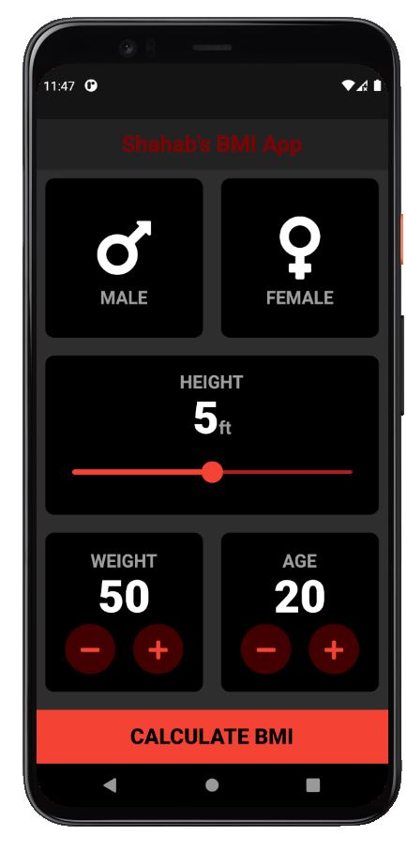**Output:**

